Criw Cymraeg
Newsletter Autumn 2023

Hello, we’re Crwys' Criw Cymraeg and we are here to tell you some ways we promote Welsh in our school. But before you read our wonderful newspaper here is a funny Welsh joke. "Young Dylan comes home from school and tells his mam he’s been given a part in the school play "wonderful" says his mam "what part did you get?" asked his mam. "I got the Welsh husband “says Dylan. His mum says “go back and say you want a real speaking part".

We are a group of 8 people there are 2 year 6’s; Maisy and Lloyd 2 year 5’s; Evie and Elis,2 year 4’s; Penny and Annie and 2 year 3’s Olivia and Lewys, with "young" teacher Mrs Davies. We love our job as Criw Cymraeg and have a meeting every week during our Tuesday lunch break.

This year we have been working very hard to encourage our fellow pupils to understand why Welsh is so important. We have also had a lovely visit from the Welsh Whisperer where we created a song all about Crwys. Then we had a party in the chapel where we sang the song in front of the parents and had lots of fun. Now we are working towards the silver award, having achieved the bronze award. There are 10 target to earn and in each target there is 10 mini targets.

Last year we joined in with the Governs meeting to show them what we had been doing that year. We have be doing a lot this year including Shwmae Day, Welsh assembey, hosting clusters schools, the Welsh Whisperer who came to our school and we made a song about Crwys with him, fun activities on Shwmae day. We especially liked drawing Welsh themed pictures on yummy cookies. We also do some Welsh in the morning like in the register.

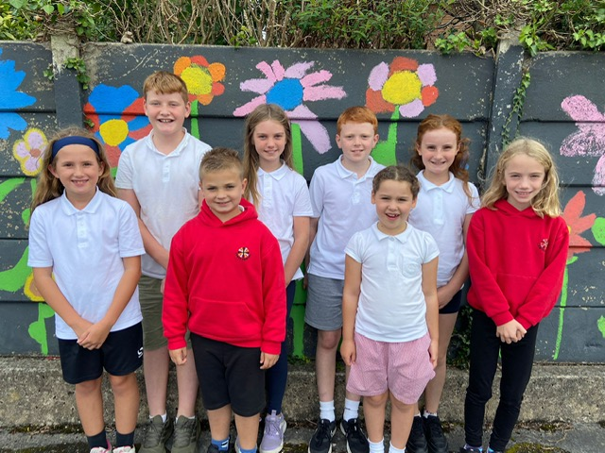
Our Criw Cymraeg

In the future we would like to achieve the silver and gold award and also meet up with some more of the cluster schools to find out how they promote Welsh in their schools.
Also, we’d liked to do more school assemblies to encourage people in our school to learn Welsh
Thank you for reading our newsletter.

